

**Project Documentation**

**Submitted by M. Sheraz Ghafoor**

**Submitted to Sir Rasikh Ali**

**Roll No SU92-BSSEM-F22-062**

**Section BSSEM-5B**

**Subject Computer Networks Lab**

Project

Network Design

**Project Overview:**

This report provides a reflective analysis of given tasks in the project documentation. The primary goal of this project was to design and implement a functional network that could support both basic connectivity and advanced network services given in the project. It details the setup of a functional network including topology, device configuration, dynamic routing, and the integration of network services such as DHCP, DNS, and HTTP. This reflective overview will also include relevant screenshots and configuration commands to illustrate the practical application of networking concepts in the project.

**Task 1** focused on establishing a robust network topology, including the configuration of network devices and the implementation of dynamic routing protocols to ensure seamless interconnectivity.

**Task 2** expanded upon this foundation by integrating different network services such as DHCP, DNS, HTTP, VLANs, Inter VLAN routing and ACLs.

**Topology**

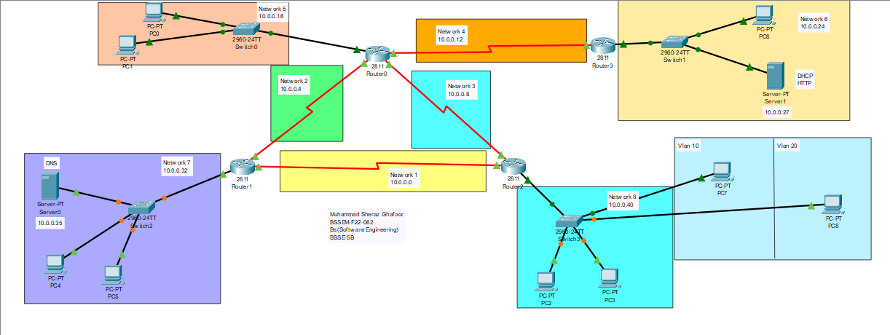

**Task 1 - Setting up a Network:**

Task 1 focused on establishing the basic network in the packet tracer. The main objectives were to configure the network devices appropriately, establish a reliable routing protocol, and verify connectivity across the network.

1. **Configuration of Network Devices:** All PCs, servers, and router interfaces were assigned IP according to the IP plan. We assigned IP addresses from class A because of our single-digit fall in class A.
2. **Implementation of Dynamic Routing:** A classless dynamic routing protocol RIP (Routing Information Protocol) was configured on the routers to facilitate efficient data routing between different network segments. This step was critical for scaling the network and enhancing its fault tolerance. We use RIP version 2 because we use subnet IP in our network.
3. **Connectivity Tests:** The network's functionality was validated through a series of connectivity tests. These tests involved pinging various network points, including each device's interface, the local router gateway, the remote router interface, and the servers to confirm the integrity and connectivity of the network.

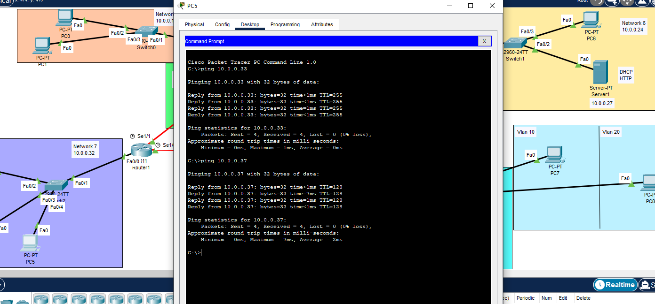

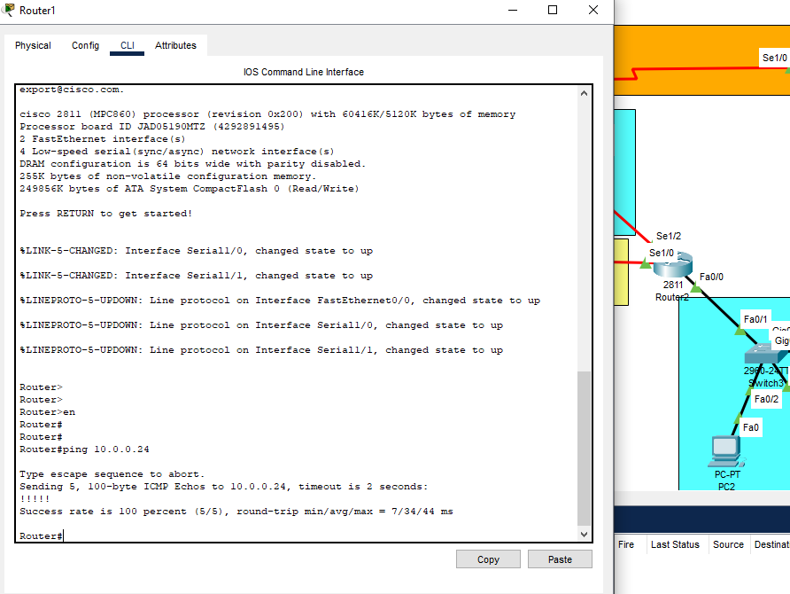

1. **Traceroute Analysis:** The traceroute command was used from a client to the server to trace the path data packets took across the network. This helped in understanding the route selection and how many hopes are between different devices.

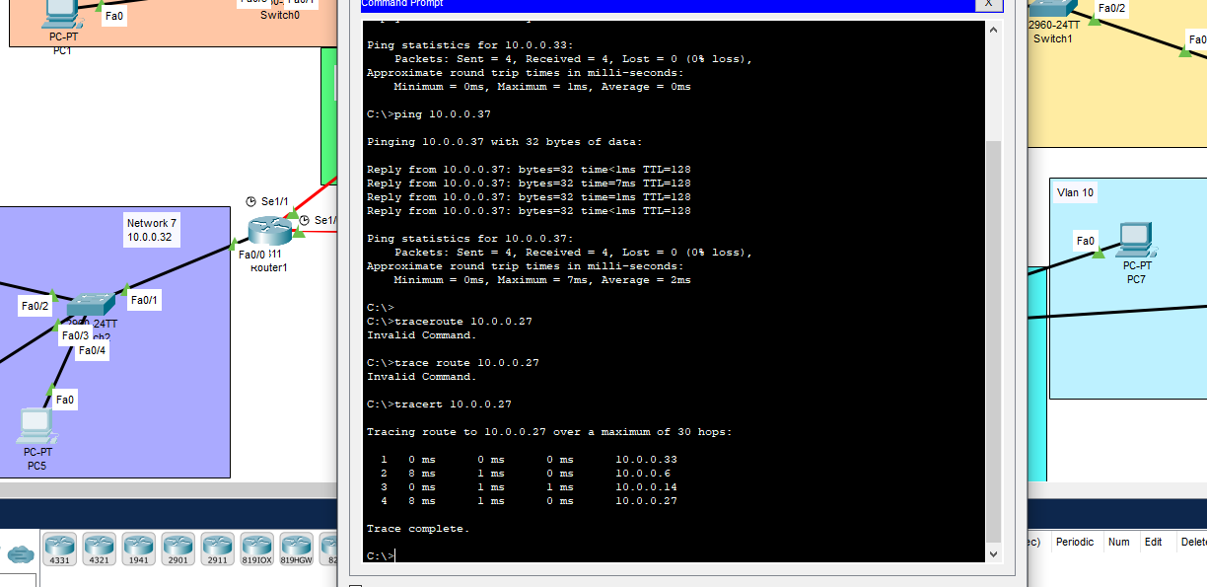

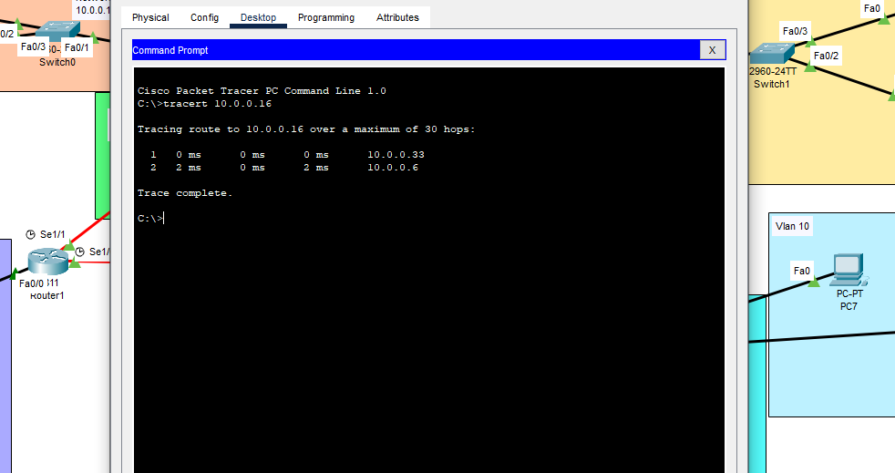

**Task 2: Configuring Network Services**

Building upon the established network from Task 1, Task 2 involved enhancing the network's capabilities by configuring additional services essential for a modern network infrastructure. The specific objectives and activities included:

1. **Subnetting:** The network was logically divided into smaller, manageable subnets based on departmental needs. This step was critical for efficient network management and security. We use one IP of class A 10.0.0.0 divided into 8 subnets and use two private networks for VLANs. Here is the IP plan

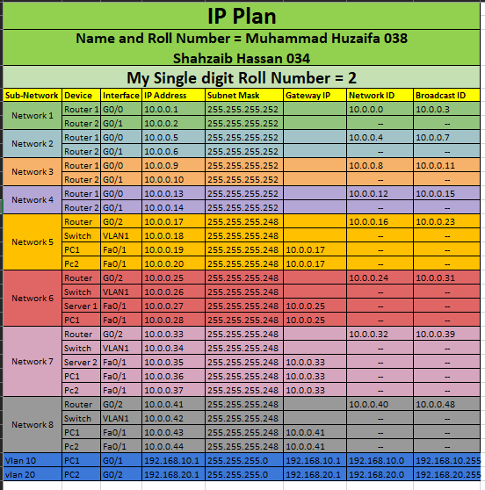

1. **DHCP Configuration:** Dynamic Host Configuration Protocol (DHCP) was implemented to automate the IP address allocation process. This setup ensured that client PCs could dynamically receive IP addresses, default gateways, subnet masks, and DNS server addresses. DHCP server is configured in Network 6 that gives IP addresses to Clients in Network 5, 7 or 8.
2. **Web Server:** Web servers were configured on designated machines to host web pages accessible via the URL sheraz.superior.edu.pk. This activity demonstrated the practical setup of web hosting within a network. HTTP server exists in Network 7 so anyone from any network wants to access sheraz.superior.edu.pk its query moves to the HTTP server connected in Network 6.
3. **DNS Services:** DNS servers were established to facilitate both forward and reverse lookup processes. This configuration is used for resolving the custom URL sheraz.superior.edu.pk to the IP address 10.0.0.27 of the web server. DNS server is attached in Network 7

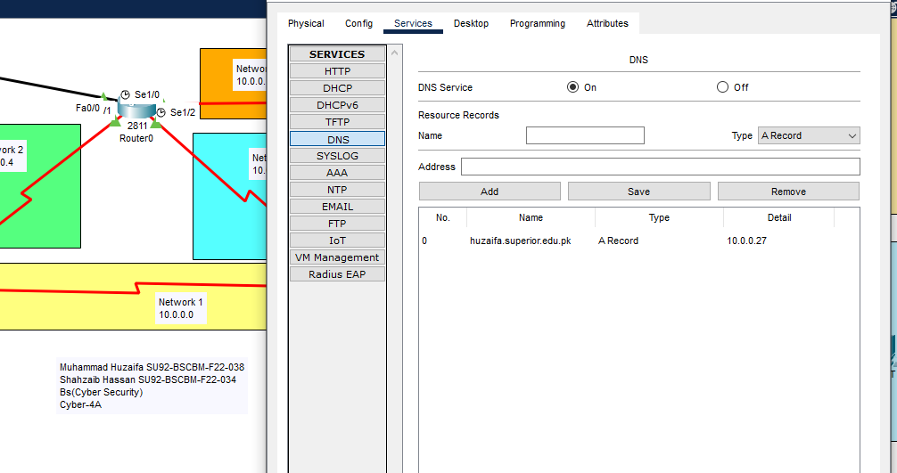

1. **Routing:** We perform two types of routing one is default routing which is used to connect different networks connected with routers. The RIP version 2 is used in Dynamic routing and the other one is Inter Vlan Routing which is also called Router on a Stick and is used to communicate between different VLANs.
2. **VLANs:** VLANs were also configured to segment the network further, based on departmental lines, enhancing security and traffic management. There are two VLANs 10 and 20 created in Network 8 and also configured Inter Vlan Routing so the pcs in VLANs can communicate with each other.
3. **NAT/PAT Implementation:** Network Address Translation (NAT) and Port Address Translation (PAT) were set up to allow seamless internet access for internal users while keeping internal network addresses private. PAT overload is configured in Network 8 so the private IP address uses ports to communicate outside the network.
4. **Access Control Lists (ACLs):** ACLs were implemented to control the ingress and egress traffic within the network, bolstering security by specifying which resources could be accessed by whom. The ACLs are configured on Router 3 so any traffic that comes from Network 5 is blocked and all other traffic is permitted.
5. **Integration of IoT Devices:** IoT devices were added to the network, and configured to ensure their compatibility and communication with existing network infrastructure.

**Conclusion:**

Completing this network project in Cisco Packet Tracer has significantly enhanced my practical understanding of network setup and management. Throughout the project, from the initial configuration in Task 1 to the complex service integrations in Task 2, I faced and overcame various challenges, each offering valuable insights into the real-world demands of network engineering.

Moving forward, I aim to build on the skills and knowledge acquired through this project by exploring more complex networking scenarios, potentially involving hybrid networks and cloud integrations, and by staying updated with the latest networking technologies and best practices.